Supplemental Materials

Table S1. Dendrometry attributes applied for the characterization of the forest structure.
Dendrometric Attributes | Method
Tree height [H_{t}, m] | * Estimated by clinometer.
Stem length [h_{f}, m] | * Estimated by clinometer.
Crown height [h_{c,} m] | $hc=Ht-hf$
Crown diameter, larger [D, m] and lower [d, m] | Based on measurement of 2 diameters: in the North-South and East-West direction by a measuring tape.
Crown projection Area [CA, m²]. | CA$=\frac{D.d.π }{4}$
Diameter at breast height [D, cm]. | $$DBH=\frac{CBH}{π}$$  CBH = circumference at breast at 1.30 m above soil ground level, measured by a tape (cm).

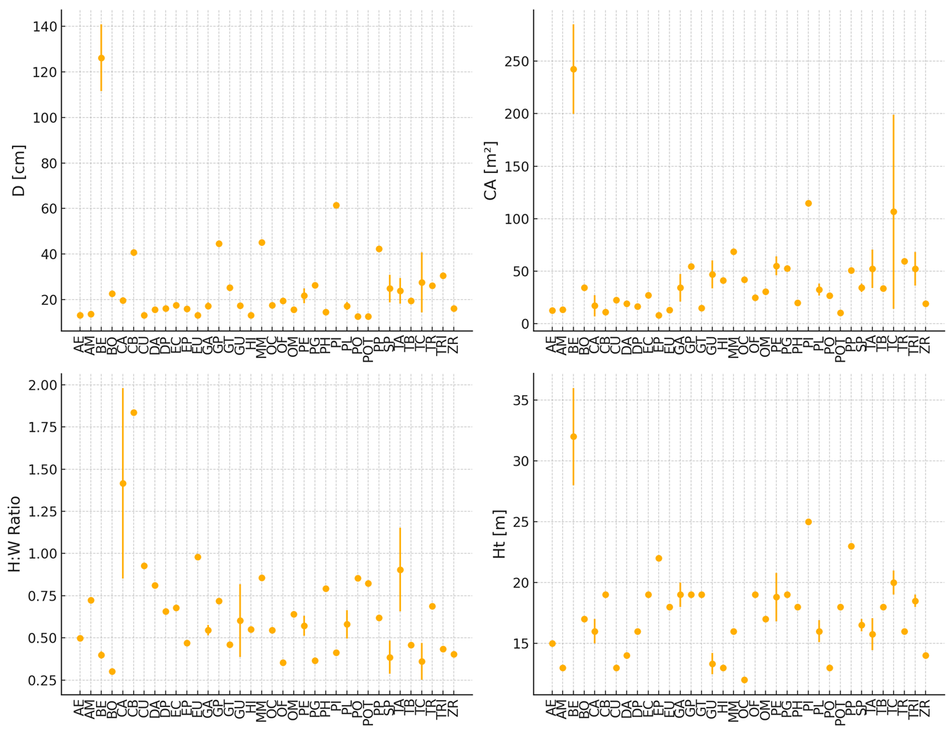Figure S1. Tree structural traits for 37 trees species. Amazon Rainforest, Rondônia, Brazil.

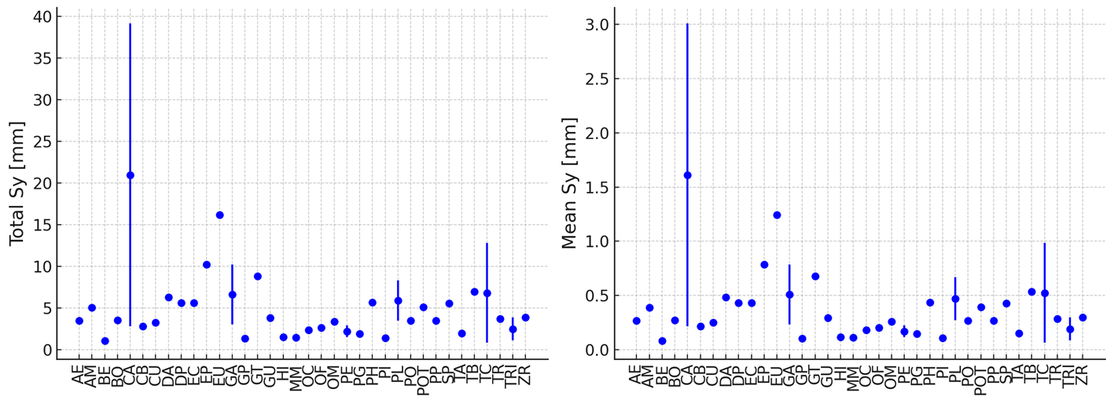
Figure S2. Stemflow for the 37 tree species. Jamari National Forest, Rondônia – Brazil.

