Article Title
Crown network datasets of Caatinga´s tree Cenostigma pyramidale (Tul.) Gagnon & G.P.Lewis (Leguminosae - Caesalpinoideae)
Authors
Dilma Maria de Brito Melo Trovão¹, Gyslaynne Gomes da Silva Costa² and Carlos Henrique Britto de Assis Prado³

Affiliations

¹State University of Paraíba, Center for Biological and Health Sciences, Department of Biology, Campina Grande, Paraíba, Brazil, 58429-500.

²Postgraduate Program in Ecology and Natural Resources, Federal University of Ceará, Fortaleza, Ceará, Brazil, 60440-900.

³Federal University of São Carlos, Center for Biological and Health Sciences, Department of Botany, São Carlos, São Paulo, Brazil, 13565-905.

Corresponding author(s)

Carlos Prado. caique@ufscar.edu.br. Number phone: +55-16-33519562
Abstract
Properties of woody crown networks of Cenostigma pyramidale (Tul.) Gagnon & G.P.Lewis (Leguminosae - Caesalpinoideae) growing under natural conditions in Caatinga vegetation area. The data are useful in plant ecophysiology, plant functional ecology by researchers investigating the woody crown traits. We obtained the data directly from a skeletonized representation of the woody crown in a two-dimensional space by hand drawing. Subsequently, the nodes counted, and their proportions (decomposition), the distances between the different types of nodes (topology), and the values ​​of network properties (the combination of decomposition and topology) were obtained.

Keywords: biological network, crown structure, network theory, plant architecture

Specifications Table

Subject | Biology, botany, plant ecology, woody crown network
Specific subject area | Botany, Functional Plant Ecology, Network theory, Plant architecture, Plant Ecology, Plant Ecophysiology
Type of data | Figures - png  Tables  Drawings
How data were acquired | Data were obtained from the observation of fourteen individuals from tree species of Caatinga vegetation growing under natural conditions at the Northeast of Brazil in Paraiba State, located at the Fazenda Pocinho (7º29'46" S, 35º58'12" W) in the municipality of Barra de Santana, State of Paraíba, Brazil. The woody crowns were drawn (skeletonized) in the 2-D format as rooted trees resulting in networks with nodes and connectors. The data of decomposition, topology, and properties captured by skeletonized crowns.
Data format | Figures - Png  Tables  Drawings
Experimental factors | No pre-treatment conducted. Data collected under natural conditions. Electronic or electric equipment was not necessary. Only drawings of skeletonized woody crowns on paper needed for compiling the datasets.
Parameters for data collection | No special conditions of environment or pre-treatments were necessary for data collection. Data collected under natural conditions. No electric or electronic equipment required for acquiring the datasets. Only drawings of skeletonized woody crowns on paper needed for compiling the datasets.
Description of data collection | Nodes (NO) and connectors (CO) were represented in a drawing forming a network of the woody crown from the soil surface to the last branches. After representing the woody crown and counting the total number of nodes, we adopted three Woody Crown Network (WCN) size categories (S). Individuals with up to 100 nodes comprised the category S1. S2 = between 101-300 nodes. S3 = above 300 nodes. The woody crown network of fourteen individuals was collected (n=5 in S1 and S2, and n=4 in S3) and individually represented in a two-dimensional space by drawings.
Data source location | Fragmet of Caatinga located in Fazenda Pocinho (7º29'46" S, 35º58'12" W) in the municipality of Barra de Santana, state of Paraíba, Brazil.
Data accessibility | Repository of Federal University of São Carlos
Related research article | An article under construction. Possible title: Decomposition, topology, and properties of different sizes of woody crown networks of Caatinga tree species Cenostigma pyramidale.  Dilma Maria de Melo Trovão, Gyslaynne Gomes da Silva Costa and Carlos Henrique Britto de Assis Prado

Value of the Data
- Dataset holding 14 Cenostigma pyramidale individuals, based on woody crown network
- Network models based on the crown architecture.
- Useful to compare growing patterns and Hydraulic vulnerability in woody Caatinga’s species
- Information to evaluate some crown attributes associated with decomposition, topology, and properties of the woody crown network
- Characterizes navigability, vulnerability, symmetry, asymmetry, and complexity of woody crowns.
- Useful to detect patterns of crown structure

Data 1 (Drawings). Fourteen images representing the Woody Crown Networks (WCN) of Caatinga's tree species Cenostigma pyramidale (Tul.) Gagnon & G.P.Lewis (Leguminosae - Caesalpinoideae) in a bi-dimensional space showing the relative positions of all nodes (NO) and connectors (CO). The segments networking the NO or merely emerging from them without another connection are the CO represented by solid black lines in WCN. NO represented by circles occupies a specific position receiving one and emitting two or more CO. It was possible to distribute NO in categories according to its location and the number of CO attached. After representing the woody crown and counting the total number of nodes, we adopted three Woody Crown Network size categories (S). Individuals up to 100 nodes comprised the category S1, between 101-300 nodes, the category S2, and S3 above 300 nodes. The WCN of fourteen individuals (n=5 in S1 and S2, and n=4 in S3) were individually represented in a two-dimensional space (Figure 1). The initial node (IN) was the first node starting from the base region towards the apical meristem. The segmentation of the Woody Crown Network of the crown began in the IN. The regular node (RN) was considered the one with up to four connectors, and the emission node (EN) contained four or more connectors. The last nodes of the crown were called final nodes (FN).
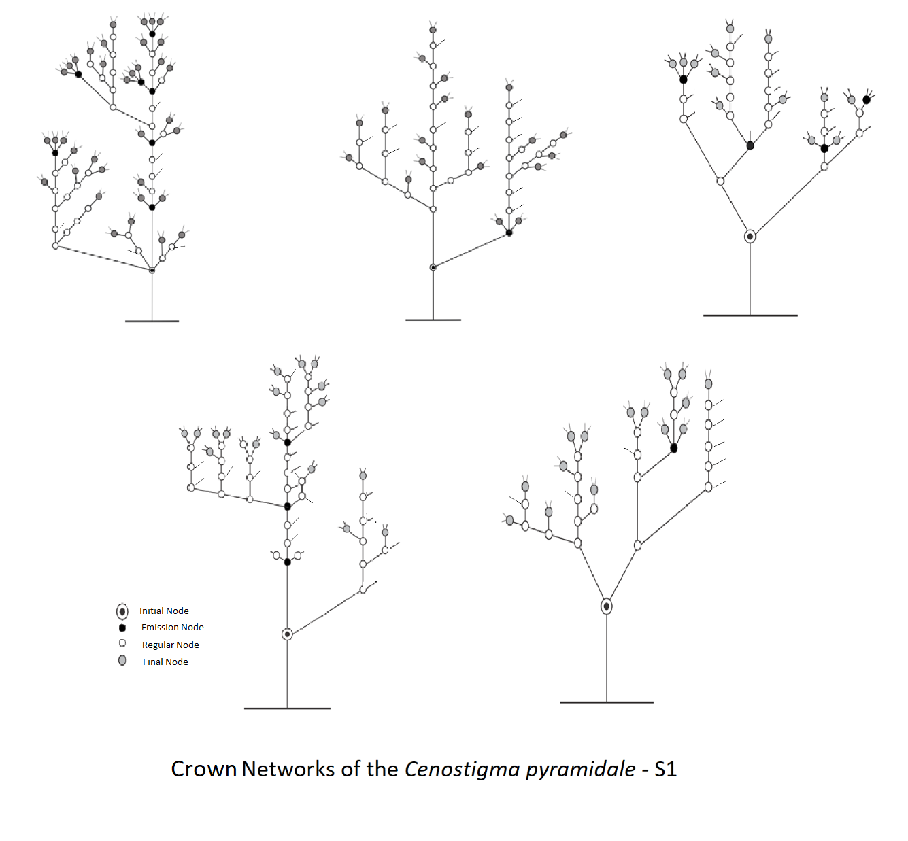

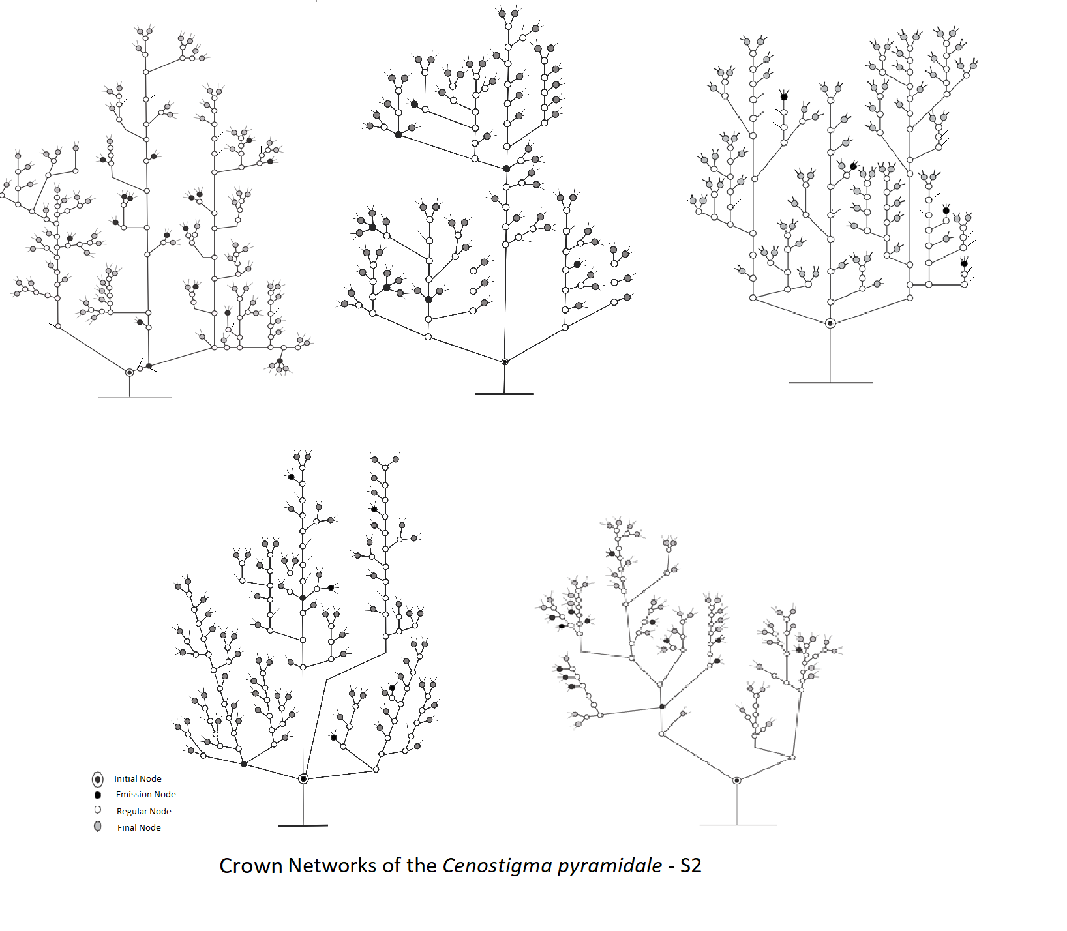

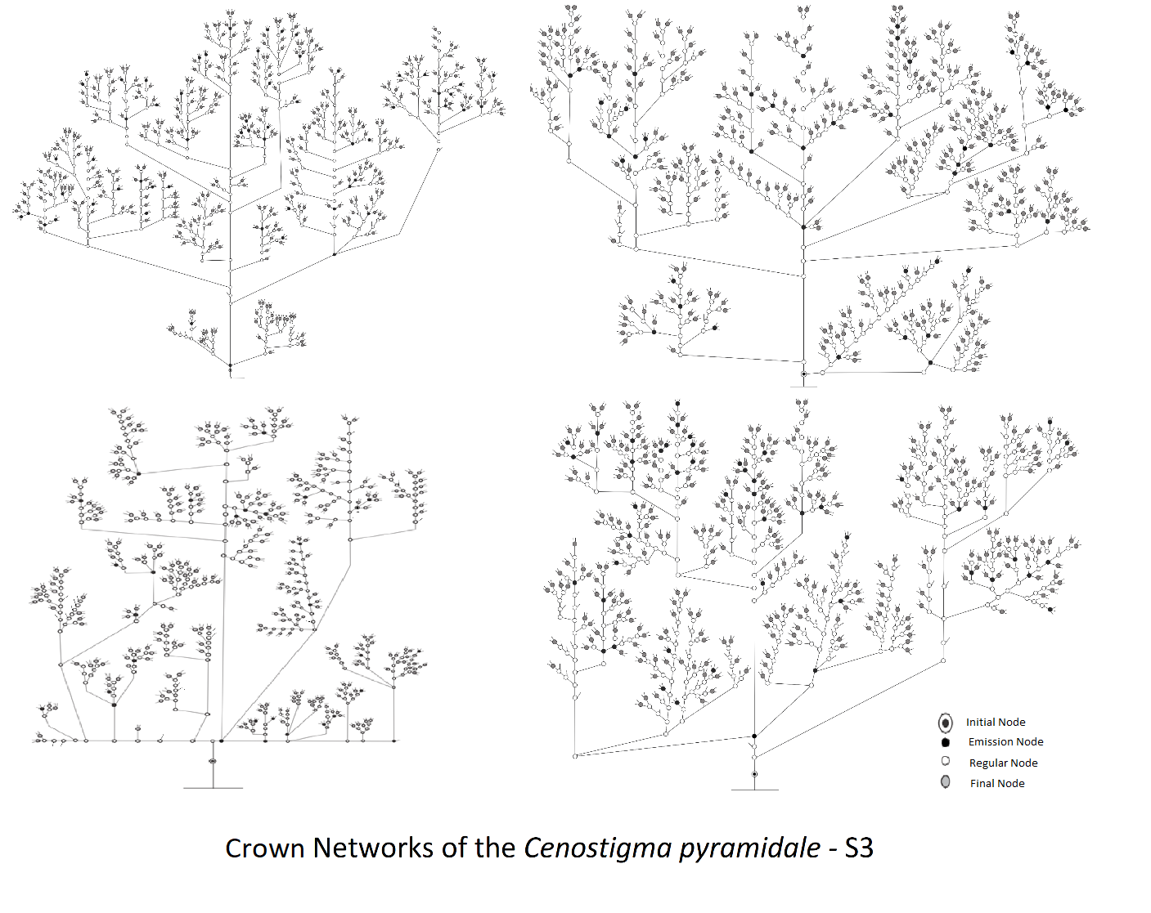

Data 2 (Table). After the representation of the Woody Crown Network (WCN) in a bidimensional space by drawings, it was possible to count the number of the nodes (NO) and connectors (CO) and the different types of NO. The number of CO between types of NO represented the distances separating them in the WCN (Wuchty et al., 2003). The length IN-FN determined by counting the connectors between the corresponding nodes resulting in the number of CO between IN and FN. The length IN-EN determined by the number of CO between IN and EN counting the connectors between the corresponding nodes. That decomposition and topological information collected using the drawings represented the woody crown networks of the fourteen individuals grouped in three sizes (S1, S2, and S3). Combining decomposition (number of nodes and connectors and the proportions of them), and topology (distances between different types of nodes) it was possible to obtain the properties of networks: Navigability (NAV), Symmetry (SYM), Asymmetry (ASY), Complexity (COM) and Vulnerability (VUL). All data of decomposition, topology, and properties are in Table 1.

Table 1. Decomposition and topological values of the woody crown network (WCN) of the tree species Cenostigma pyramidale growing in natural conditions in Caatinga vegetation exhibiting three sizes delimited by the number of nodes, <100(S1), 101-300(S2), and >300(S3), respectively, small, middle, and large. Ind. = number of individuals in each size category. ΣNO = total of nodes. ΣCO = amount of connectors. ΣCO/ΣNO = ratio of total connector/total node. CO per NO = number of connectors per node. ΣRN = total of regular nodes. ΣFN = total of final nodes. ΣEN = the number of emission nodes. IN-FN = distance in connectors between initial and final nodes. IN-EN = distance in connectors between initial and emission nodes.
CN | Ind. | ΣNO | ΣCO | ΣCO/ΣNO | CO per NO | ΣRN | ΣFN | ΣEN | IN-FN | IN-EN
S1 | 1 | 76 | 155 | 2.1 | 3.0 | 31 | 36 | 7 | 3.0 | 9.8
S1 | 2 | 51 | 101 | 2.0 | 3.0 | 29 | 19 | 1 | 4.3 | 8.4
S1 | 3 | 36 | 77 | 2.0 | 3.1 | 18 | 14 | 4 | 3.0 | 7.0
S1 | 4 | 56 | 112 | 2.0 | 3.0 | 31 | 36 | 7 | 6.9 | 6.5
S1 | 5 | 37 | 74 | 2.0 | 3.0 | 20 | 15 | 1 | 1.0 | 7.4
S2 | 1 | 206 | 406 | 2.1 | 3.0 | 107 | 92 | 16 | 9.3 | 19.6
S2 | 2 | 139 | 229 | 1.6 | 2,9 | 59 | 69 | 7 | 5.9 | 18.8
S2 | 3 | 178 | 665 | 2.2 | 3.0 | 95 | 80 | 4 | 7.5 | 21.4
S2 | 4 | 174 | 610 | 1.9 | 3.1 | 88 | 85 | 7 | 6.0 | 24.2
S2 | 5 | 132 | 489 | 2.0 | 3.1 | 69 | 62 | 13 | 7.0 | 16.7
S3 | 1 | 825 | 1613 | 1.9 | 3.0 | 398 | 399 | 57 | 12.6 | 58.6
S3 | 2 | 727 | 1466 | 2.0 | 3.0 | 341 | 355 | 40 | 9.6 | 64.0
S3 | 3 | 603 | 1171 | 1.9 | 3,0 | 294 | 265 | 29 | 9.0 | 54.4
S3 | 4 | 747 | 1446 | 2.0 | 3.1 | 398 | 399 | 57 | 12.4 | 57.7

Table 2. Properties of woody crown network of the tree species Cenostigma pyramidale growing in natural conditions in Caatinga vegetation exhibiting three size categories (S1, S2, and S3) delimited by the number of nodes, <100, 101-300, and >300, respectively. Ind. = individuals. NAV = navigability. VUL = vulnerability. SYM = symmetry. COM = complexity.

WCN | Ind. | NAV | VUL | SYM | COM
 | 1 | 9.8 | 0.124 | 0.091 | 831
 | 2 | 8.4 | 0.137 | 0.207 | 246
S1 | 3 | 7.0 | 0.144 | 0.386 | 93
 | 4 | 6.5 | 0.178 | 0.081 | 691
 | 5 | 7.4 | 0.139 | 0.875 | 42
 | 1 | 19.6 | 0.062 | 0.099 | 2071
 | 2 | 18.8 | 0.083 | 0.139 | 998
S2 | 3 | 21.4 | 0.060 | 0.174 | 1026
 | 4 | 24.2 | 0.046 | 0.123 | 1413
 | 5 | 16.7 | 0.070 | 0.167 | 788
 | 1 | 58.6 | 0.026 | 0.056 | 14774
S3 | 2 | 64.0 | 0.024 | 0.114 | 6392
 | 3 | 54.4 | 0.027 | 0.123 | 4904
 | 4 | 57.7 | 0.024 | 0.123 | 6052

Acknowledgments

At the period of data acquisition, Gyslaynne G. S. Costa received a scholarship from the Brazilian agency “Coordination for the Improvement of Higher Education Personnel” (CAPES). There was not any additional financial support to collect the data or to prepare this dataset. The authors would like to thank Ellori Mota for making the drawings in a publication format.

Competing Interests
The authors declare that they have no known competing for financial interests or personal relationships which have, or could be perceived to have, influenced the work reported in this article.

References
Wuchty S, Oltvai ZN, Barabási AL (2003) Evolutionary conservation of motif constituents in the yeast protein interaction network. Nature genetics 35(2):176. https://www.nature.com/articles/ng1242

